Speed dating data

matches: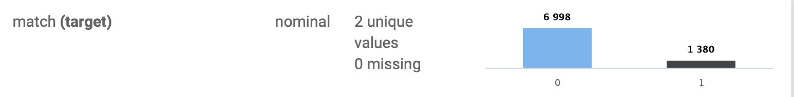

Gender: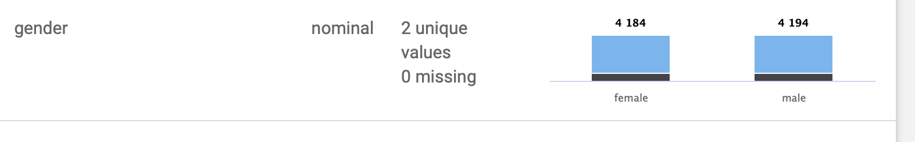

Age: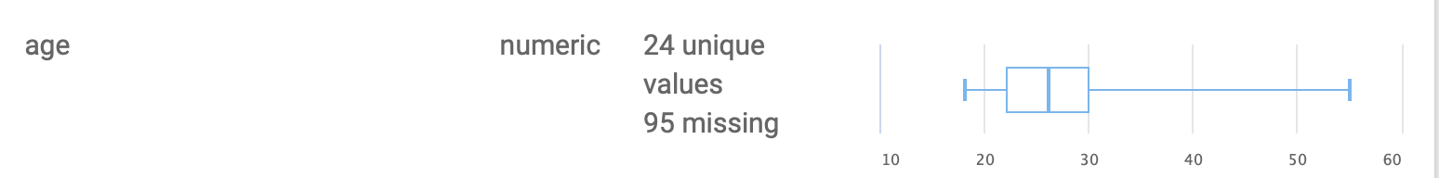

Same Race: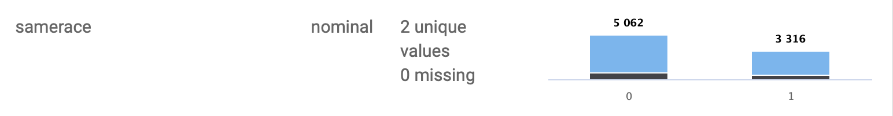

<https://www.openml.org/d/40536>

Changes:

numeric numbers from 1-0 to yes and no

ranges to low medium high

average for missing numbers in dat set

deleted a bunch of columns